# INDEX

|  |  |  |  |  |
| --- | --- | --- | --- | --- |
| **Sl. No.** | |  | **Chapters** | **Page no** |
|  | Abstract | | ………………………………………………………... | 1 |
| 1 | Introduction…………………………………………………………. | | | 2 |
| 2 | Literature Survey……………………………………………………. | | | 4 |
|  | 2.1 | Existing System…………………………………………….. | | 4 |
|  | 2.2 | Proposed System……………………………………………. | | 5 |
| 3 | Software Requirement Specification ……………………………... | | | 6 |
|  | 3.1 | Introduction………………………………………………… | | 6 |
|  | 3.2 | Purpose ..…………………………………………………… | | 6 |
|  | 3.3 | Scope……………………………………………………….. | | 6 |
|  | 3.4 | Software Requirements ..…………………………………… | | 6 |
|  | 3.5 | Hardware Requirements …………………………………… | | 6 |
|  | 3.6 | Functional Requirements ………………………………….. | | 7 |
|  | 3.7 | Non-Functional Requirements ……………………………. | | 7 |
| 4 | System Design …………………………………………………….. | | | 8 |
|  | 4.1  4.2  4.3 | Architecture Diagram ………………………………………  Data Flow Diagram ………………………………………..  ER Diagram ……………………………………………….. | | 8  9  10 |
|  | 4.4 | Database design ……………………………………………. | | 11 |
|  | 4.5 | Use case Diagram ………………………………………….. | | 12 |
|  | 4.6 | Sequence Diagram …………………………………………. | | 13 |
| 5 | Implementation …………………………………………………….. | | | 14 |
|  | 5.1 | Technologies used …………………………………………. | | 14 |
|  | 5.2 | Module Explanation ……………………………………….. | | 23 |
|  | 5.3 | Source Code ………………………………………………... | | 25 |
| 6 | Testing ……………………………………………………………… | | | 31 |
|  | 6.1 | Introduction ……………………………………………...... | | 31 |
|  |  | 6.1.1 | Test objectives ……………………………………… | 31 |
|  |  | 6.1.2 | Testing strategies …………………………………… | 31 |
|  | 6.2 | Test cases and results (Test Report) ………………………. | | 32 |
| 7 | Conclusion …………………………………………………………. | | | 33 |
| 8 | Future Enhancements ………………………………………………. | | | 39 |
| 9 | Bibliography ………………………………………………………... | | | 40 |
| 10 | User Manual ………………………………………………………... | | | 41 |

**ABSTRACT**

***“GoInnBus”*** *is a web application which helps the Transport Companies for tracking their buses and to manage the details of the buses. Through this application owner can register his/her organization buses. During the registration process the owner has to register the buses with bus details such as RC number, Bus number, Purchase date, and Registration date along with bus image. Once the bus get registered into the system the owner has to provide soft copies of the documents of the buses such as bus fitness certificate, bus tax certificate, bus insurance certificate etc. This system provides facility of notifying the expiry date of the particular document [through EMAIL] before one month of due date of the documents by taking the expiration date at the time of document upload. Now owner will be provided with privilege for viewing the bus documents as well as complete bus details. The owner/First level manager of the organization can track the exact position of the bus on the map.*

**Chapter 1**

**INTRODUCTION**

**Prepare the content of the report as per the index page given in this document.**

**Fonts and styles**

**Chapter Nos: Times New Roman 16 with Left alignment. (Chapter 1)**

**Chapter Names: CAPITAL LETTERS Times New Roman 16 with Center alignment (INTRODUCTION)**

**Sub Headings: Times New Roman 14 with Left alignment**

**Chapter No’s, Chapter names and Subheadings should *not be* underlined.**

**Page numbers should start from Chapter No. 1. Do not put page numbers for Content Page, Abstract Page.**

**Body Text: Times New Roman 12 with Justification**

**“GoInnBus”** is a web based application which helps the organization for tracking their buses along with the details regarding the buses. Manager/owner of the organization can track the current location of the buses along with bus details such as Bus No., RC number, date of registration of the bus etc. It helps in an easy management as well as tracking the exact location of the buses. The owner and higher level manager can have access to this system. This system does not use any GPS modules rather driver mobile phone’s GPS is used for tracking the location of the bus. The system also provides the facility to add or modify the details of the buses and also the owner/higher level manager can upload the recent updated documents of the buses.

As the system is a web based application, so it is available 24/7 and it is cost effective because the use of external GPC device is not required here as the system uses driver mobile phone’s GPS for tracking the current location. This system provides easy to use interface for the owner/higher level manager. In this system, the owner/higher level manager can view details of the buses along with bus image and also the documents of the buses. The bus documents can be saved to the system and also the owner/manager can view the documents by enlarging the content of the document for specific information.

By this system the owner as well as First level manager will get the email notifications when the new bus is get registered to the system and also before the expiry date of any bus documents. This will help the organization to renew the particular documents within expiry date and hence not paying the extra money for late renewal of documents. This system helps the owner to track the exact location and also through this system the owner/higher level manager will get to know where bus is and how much time it is idle in the same location. Hence it helps the owners to get to know the fraud done by employees by keeping idle at bus stations and also the manager/owner can take necessary actions on the employees.

Hence the system will help its users in easy management of the bus details and also to know the exact location of the bus and also to know whether the bus is travelling or idle in state. And it is a cost efficient system as it does not use any external GPS modules for tracking purpose instead it uses the GPS of driver mobile device. And also the owner/higher level manager can get to know which bus is assigned to which path.

**Chapter 2**

**LITERATURE SURVEY**

Now a days providing better information to the owner/managers of the bus companies with respect to exact location of the buses, bus details along with maintaining the documents of the buses and notifying the due date of any of the bus documents and also maintaining the records of the buses which are assigned to the particular locations is mostly manual and it is difficult for the owners/managers of the organization for maintenance. In the virtue of this, we are developing GoInnBus application which helps the owners/managers of the bus organization in managing and maintaining the information efficiently as the application provides easy to use graphical user interface for its users.

### Existing System

Now a days we are having GPS module in most of the buses to track the bus location which requires high cost and also it is very hard to know the exact position of the vehicle. Assigning the bus to a particular location and maintaining its timings is manual till date. There is no appropriate system to know the idle state of the bus once the bus is assigned to particular employees as most times the employees make fraudulence by not reaching the destinations in appropriate timings instead stopping the bus at bus stations for longer time. In most of the vehicles, documents are not maintained properly and are maintained manually till date and also there is no automated notifications regarding the due date of the documents. The paper (hard copy) documents may lead to loss and fraudulence of data in many cases. It is difficult for the owners to maintain the bus details and documentations because of paper works.

#### Drawbacks of present system are

* + - Use of GPS module leads to more cost.
    - Manually the vehicles are assigned for the duty.
    - Maintaining the timing and recording those timing is mostly manual.
    - No system to know the idle state of the bus more the actual time required.
    - Manual maintenance of bus documents.
    - No facility to notify the due date of the bus documents and manual procedure is followed.

### Proposed System

To overcome existing system problems we are developing a web. Instead of using the dedicated GPS device, we are using mobile device GPS in each buses to dynamically track the bus location. The driver mobile GPS is used to track the exact location of the buses. Maintaining the bus documents is easier for usage of the users in case of necessity. The administrator/owner/manager can get to know how the particular bus is operated in the route and can have control over employees. The bus documents such as Insurance certificate, bus fitness certificate, tax certificate and other documents can be stored in the system and can be used whenever necessary. And the notification for the renewal of the documents is sent to the owner and manager. The administrator/owner/higher level manager has the overall view of the application. The system provides the facility for the users to give feedback and the administrator can use these feedbacks to improve the system and transportation service. The driver mobile GPS is enabled and location of the bus is tracked based on the mobile GPS instead of using GPS device separately in the bus. The system provides facility for the owner/higher level manager to add new buses and new routes.

* + - Registration of new bus to the system.
    - Users can view complete information of the particular bus on click of a button.
    - Owner/higher level manager can modify the bus details or can delete the bus along with all details from the system.
    - The system maintains all the documents of the buses and can be used by users whenever required.
    - This system provides email notifications to the owners/higher level managers regarding due date of the bus documents one month prior.
    - The users can add/modify the bus details when the documents are renewed and new documents can be uploaded to the system.
    - The users can send feedback to the administrator for any improvements of the system.

**Chapter 3**

**SOFTWARE REQUIREMENT SPECIFICATION**

**The SRS is not written as per the standard. Please refer the below link and rewrite the SRS.**

[**https://krazytech.com/projects/sample-software-requirements-specificationsrs-report-airline-database**](https://krazytech.com/projects/sample-software-requirements-specificationsrs-report-airline-database)

* 1. **Introduction**

The Software Requirement Specification is developed to address the user requirement for the development of an application. This document provides functional and non-functional requirements for “GoInnBus” application.

### Purpose

The purpose of this software requirement specification is to properly document the requirements which are necessary in order to construct this project details. This project is to develop online web application, which helps to track the exact location of the bus and to maintain and manage the bus details. The system provides the reliable service, faster access and flexibility to its users.

### Scope

The project “GoInnBus” is a web application, which is capable of maintaining and managing the bus details and also tracking the exact location of the bus. The users of this system are Owners and Higher level managers.

### Software requirements

* + - Front end: HTM5
    - Operating system: Windows 7 and later versions.
    - Database: MySQL
    - Middleware: PHP
    - Server: WAMP Server

### Hardware Requirements

* + - 40 GB HDD
    - 1 GB RAM
    - Processor Pentium4
  1. **Functional Requirements** 
     + Registration of the new buses along with its details and bus image.
     + Viewing complete details of the bus along with bus image.
     + Uploading bus documents with respect to bus number.
     + Sending email notification to the owners/managers of the bus regarding the due date of the particular bus document.
     + Viewing list of registered buses in the system and facility to modify the bus details or delete the bus from the system.
     + Tracking the bus in the map to know the exact position of the bus.
     + Sending the feedback regarding any improvements/changes in the systems.

### Non-Functional requirements

* + - Availability The application should be available for 24 hours of the day.
    - Usability The application interface should be easier to use by the users.
    - Learnability The users of the application must be able to understand the application easily without any complexities.
    - Visibility The application’s interface must be clearly visible to know the results with no problems of visibility.
    - Correctness The results of the system must be correct and should satisfy the users with accurate results.

**Chapter 4**

**SYSTEM DESIGN**

**Refer the Index page for sequencing the subtopics.**

**Data Flow Diagram**

**Prepare a DFD according to the attached documents or URL** https://computerdynamics.weebly.com/uploads/2/5/7/6/25764826/dfd_examples.ppt

Do not write steps required in DFD. Draw only DFD and write explanation if necessary.

Use any of the following tools for drawing DFD.

<https://www.visual-paradigm.com/>

<https://www.edrawsoft.com/download-edrawmax.php>

<https://www.lucidchart.com/documents/edit/e01d8088-4cf6-4d20-ad68-d0168e4ad77b/0>

<https://www.lucidchart.com/documents#docs?folder_id=home&browser=icon&sort=saved-desc>

<https://cloud.smartdraw.com/>

https://www.smartdraw.com/downloads/

Data Flow Diagram is a simple pictorial representation or model for system behavior. It specifies, “What is to be done but not how is to be done”. It describes the logical structure of the system. It relates data or information to various processes of the system. It follows top-down approach.

**Steps required in DFD**

1. Identify system, processing transformations
2. Transactions concerned with reading, validating and formatting inputs.
3. Identify input transformations.
4. Transformations concerned with reading, validating and formatting inputs.
5. Identify output transformations.
6. Transformations concerned with formatting and writing output. Group under the output Function.

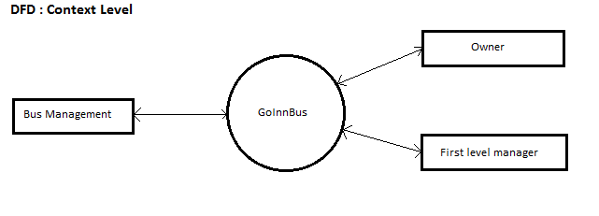

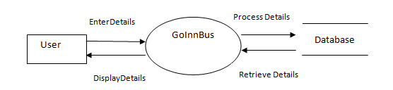

**Architecture Diagram**

**Draw Architecture diagram as per the Figure 6.1 – The Architecture of Packing Robot System from Software Engineering, Ian Sommerville 9th Edition.**

The architectural design defines the relationship among major structural element of the program. Architecture diagram shows the relationship between different components of system. This diagram is very important to understand the overall concept of system.

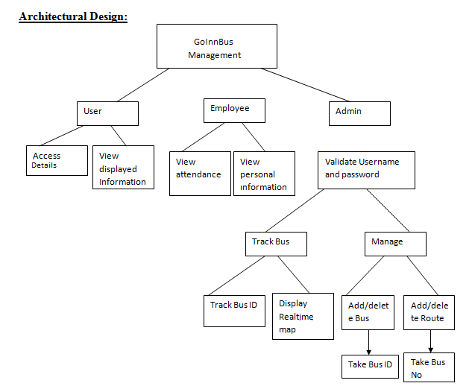

**ER Diagram**

# **Use ERD plus for a database modeling tool for creating Entity Relationship Diagrams, Relational Schemas, Star Schemas, and SQL DDL statements. Refer the link https://erdplus.com/#/**

An entity-relationship model (ERM) is an abstract and conceptual representation of data. Entity-relationship modeling is a database modeling method, used to produce a type of conceptual schema or semantic data model of a system, often a relational database, and its requirements in a top-down fashion. Diagrams created by this process are called entity- relationship diagrams, ER diagrams.

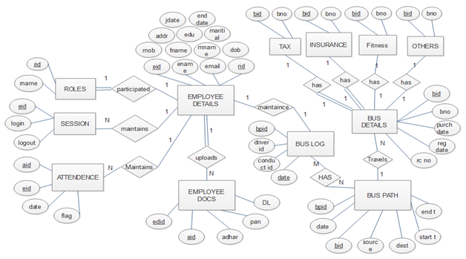

**Database Design**

**Correct the visibility of the tables**

**BusDetails table**

|  |  |  |
| --- | --- | --- |
| **Fields** | **Data Type** | **Constraints** |
| Bid | Int(11) | Primary key |
| Bno | Varchar(30) | Not null |
| Purdate | Date | Not null |
| Regdate | Date | Not null |
| Rcno | Varchar(50) | Not null |
| Busimage | Varchar(500) | Not null |

|  |  |  |
| --- | --- | --- |
| **Fields** | **Data Type** | **Constraints** |
| **Bid** | **Int(11)** | **Primary key** |
| **Bno** | **Varchar(30)** | **Not null** |
| **Purdate** | **Date** | **Not null** |
| **Regdate** | **Date** | **Not null** |
| **Rcno** | **Varchar(50)** | **Not null** |
| **Busimage** | **Varchar(500)** | **Not null** |

**BusFitness table**

|  |  |  |
| --- | --- | --- |
| **Fields** | **Data Type** | **Constraints** |
| Bfid | Int(11) | Primary key |
| Bid | Int(11) | Not null |
| url | Varchar(100) | Not null |
| Fexpirystart | Date | Not null |
| Fexpiry | Date | Not null |

**Feedback table**

|  |  |  |
| --- | --- | --- |
| **Fields** | **Data types** | **Constraints** |
| Fid | Int(11) | Primary key |
| Subject | Varchar(200) | Not null |
| Feedbacktext | Varchar(500) | Not null |

**BusInsurance table**

|  |  |  |
| --- | --- | --- |
| **Fields** | **Data types** | **Constraints** |
| Binsid | Int(11) | Primary key |
| Bid | Int(11) | Not null |
| url | Varchar(100) | Not null |
| Iexpirystart | Date | Not null |
| Iexpiry | Date | Not null |

**Bus_tax table**

|  |  |  |
| --- | --- | --- |
| **Fields** | **Data Type** | **Constraints** |
| Btid | Int(11) | Primary key |
| Bid | Int(11) | Not null |
| url | Varchar(100) | Not null |
| Texpirystart | Date | Not null |
| Texpiry | Date | Not null |

**Work_assign table**

|  |  |  |
| --- | --- | --- |
| **Fields** | **Data types** | **Constraints** |
| Aid | Int(11) | Primary key |
| Bno | Varchar(20) | Not null |
| Driver | Varchar(50) | Not null |
| Conductor | Varchar(50) | Not null |
| Timing | Timestamp | Not null |

**Role table**

|  |  |  |
| --- | --- | --- |
| **Fields** | **Data types** | **Constraints** |
| Rid | Int(11) | Primary key |
| Rname | Varchar(100) | Not null |

**Chapter 5**

**IMPLEMENTATION**

**Write only one paragraph about the technology used. Please include justification for choosing the particular technologies and tools for developing your project.**

This Phase explains the implementation of this project, software tools used and several issues. This illustrates the correctness of the project, which means whether it is satisfying the user requirements and does it holds the requirement specification as mentioned. It enables us to correct, if any error occurs.

**Why You Need WAMP, MySQL, and PHP?**

PHP is a powerful scripting language that can be run by itself in the command line of any computer with PHP installed. However, PHP alone isn't enough in order to build dynamic web sites. To use PHP on a web site, you need a server that can process PHP scripts. WAMP server allows developers to test PHP scripts locally; this makes it an invaluable piece of your local development environment.

Additionally, dynamic websites are dependent on stored information that can be and easily; this is the main difference between a dynamic site and a static HTML site. However, PHP doesn’t provide a simple, efficient way to store data. This is where a relational database management system like MySQL comes into play.

### Technologies Used

**PHP**

PHP originally stood for “Personal Home Page” and was released as a free, open source project. Over time, the language was reworked to meet the needs of its users. In 1997, PHP was renamed to the current “PHP Hypertext Preprocessor. ”PHP is generally used as a server-side scripting language; it is especially well-suited for creating dynamic web pages and client-side GUI applications. . PHP generally runs on a web server, taking PHP code as its input and creating web pages as output. The scripting language features integrated support for interfacing with databases such as MySQL, which makes it a prime candidate for building all manner of web applications, from simple personal web sites to complex enterprise-level applications.

Unlike HTML, which is parsed by a browser when a page loads, PHP is preprocessed by the machine that serves the document (this machine is referred to as a server). All PHP code contained with the document is processed by the server before the document is sent to the visitor’s browser. PHP is a scripted language, which is another great advantage for PHP programmers. PHP can be deployed on most web servers, many operating systems and platforms, and can be used with many relational database management systems. It is available free of charge, and the PHP Group provides the complete source code for users to build, customize and extend for their own use. Many programming languages require that you compile files into machine code before they can be run, which is a time-consuming process. Bypassing the need to compile means you’re able to edit and test code much more quickly Because PHP is a server-side language, running PHP scripts on your local machine requires installing a server on your local machine.

PHP is free software released under the PHP License; however it is incompatible with the GNU General Public License (GPL), due to restrictions on the usage of the term PHP. It is a widely-used general-purpose scripting language that is especially suited for web development and can be embedded into HTML. It generally runs on a web server, taking PHP code as its input and creating web pages as output. It can be deployed on most web servers and on almost every operating system and platform free of charge. PHP is installed on more than 20 million websites and 1 million web servers.

**Usage**

PHP is a general-purpose scripting language that is especially suited for web development. PHP generally runs on a web server, taking PHP code as its input and creating web pages as output. It can also be used for command-line scripting and client-side GUI applications. PHP can be deployed on most web servers, many operating systems and platforms, and can be used with many relational database management systems. It is available free of charge, and the PHP Group provides the complete source code for users to build, customize and extend for their own use.

PHP primarily acts as a filter, taking input from a file or stream containing text and/or PHP instructions and outputs another stream of data; most commonly the output will be HTML. It can automatically detect the language of the user. From PHP 4, the PHP parser compiles input to produce byte code for processing by the Zend Engine, giving improved performance over its interpreter predecessor. Originally designed to create dynamic web pages, PHP’s principal focus is server side scripting, and it is similar to other server-side scripting languages that provide dynamic content from a web server to a client, such as Microsoft’s Active Server Pages, Sun Microsystems’ Java Server Pages, and mod_perl. PHP has also attracted the development of many frameworks that provide building blocks and a design structure to promote rapid application development (RAD). Some of these include Cake PHP, Symfony, Code Igniter, and Zend Framework, offering features similar to other web application frameworks.

The LAMP architecture has become popular in the web industry as a way of deploying web applications. PHP is commonly used as the P in this bundle alongside Linux, Apache and MySQL, although they may also refer to Python or Perl. As of April 2007, over 20 million Internet domains were hosted on servers with PHP installed, and PHP was recorded as the most popular Apache module. Significant websites are written in PHP including the user-facing portion of Facebook, Wikipedia (MediaWiki), Yahoo!, MyYearbook, Digg, Wordpress and Tagged. In addition to server-side scripting, PHP can be used to create stand-alone, compiled applications and libraries, it can be used for shell scripting, and the PHP binaries can be called from the command line.

### MySQL

**MySQL** is an [open-source](https://en.wikipedia.org/wiki/Open-source) [relational database management system](https://en.wikipedia.org/wiki/Relational_database_management_system)(RDBMS). Its name is a combination of "My", the name of co-founder [Michael Widenius'](https://en.wikipedia.org/wiki/Michael_Widenius) daughter and "[SQL](https://en.wikipedia.org/wiki/SQL)", the abbreviation for [Structured Query Language.](https://en.wikipedia.org/wiki/Structured_Query_Language) The MySQL development project has made its [source code](https://en.wikipedia.org/wiki/Source_code) available under the terms of the [GNU General Public License](https://en.wikipedia.org/wiki/GNU_General_Public_License), as well as under a variety of [proprietary](https://en.wikipedia.org/wiki/Proprietary_software) agreements. MySQL was owned and sponsored by a single [for-profit](https://en.wikipedia.org/wiki/Business) firm, the [Swedish](https://en.wikipedia.org/wiki/Sweden) company [MySQL AB,](https://en.wikipedia.org/wiki/MySQL_AB) now owned by [Oracle](https://en.wikipedia.org/wiki/Oracle_Corporation) [Corporation](https://en.wikipedia.org/wiki/Oracle_Corporation). For proprietary use, several paid editions are available, and offer additional functionality.

MySQL is a central component of the [LAMP](https://en.wikipedia.org/wiki/LAMP_(software_bundle)) open-source web application software stack (and other "[AMP](https://en.wikipedia.org/wiki/List_of_AMP_packages)" stacks). LAMP is an acronym for "[Linux](https://en.wikipedia.org/wiki/Linux), [Apache,](https://en.wikipedia.org/wiki/Apache_HTTP_Server)

MySQL, [Perl](https://en.wikipedia.org/wiki/Perl)/[PHP](https://en.wikipedia.org/wiki/PHP)/[Python](https://en.wikipedia.org/wiki/Python_(programming_language))". Applications that use the MySQL database

include [TYPO3](https://en.wikipedia.org/wiki/TYPO3), [MODx](https://en.wikipedia.org/wiki/MODx), [Joomla](https://en.wikipedia.org/wiki/Joomla), [WordPress](https://en.wikipedia.org/wiki/WordPress), [phpBB](https://en.wikipedia.org/wiki/PhpBB), [MyBB](https://en.wikipedia.org/wiki/MyBB), and [Drupal](https://en.wikipedia.org/wiki/Drupal). MySQL is also used in many high-profile, large-scale [websites](https://en.wikipedia.org/wiki/Website),

including Google, Facebook, Twitter, Flickr, and YouTube.

### Features

MySQL is offered under two different editions the open source MySQL Community Server and the proprietary [Enterprise Server](https://en.wikipedia.org/wiki/MySQL_Enterprise). MySQL Enterprise Server is differentiated by a series of proprietary extensions which install as server plugins, but otherwise shares the version numbering system and is built from the same code base.

### Major features as available in MySQL 5.6

* A broad subset of ANSI SQL 99, as well as extensions
* Cross-platform support
* [Stored procedures,](https://en.wikipedia.org/wiki/Stored_procedure) using a procedural language that closely adheres to SQL/PSM
* [Triggers](https://en.wikipedia.org/wiki/Database_trigger)
* [Cursors](https://en.wikipedia.org/wiki/Cursor_(databases))
* Update table [views](https://en.wikipedia.org/wiki/View_(SQL))
* [Online DDL](https://en.wikipedia.org/wiki/Data_Definition_Language) when using the InnoDB Storage Engine.
* [Information schema](https://en.wikipedia.org/wiki/Information_schema)
* Performance Schema that collects and aggregates statistics about server execution and query performance for monitoring purposes.
* A set of SQL Mode options to control runtime behavior, including a strict mode to better adhere to SQL standards.
* [X/Open XA](https://en.wikipedia.org/wiki/X/Open_XA) [distributed transaction processing](https://en.wikipedia.org/wiki/Distributed_transaction_processing)(DTP) support; [two phase commit](https://en.wikipedia.org/wiki/Two-phase_commit_protocol) as part of this, using the default [InnoDB](https://en.wikipedia.org/wiki/InnoDB) storage engine
* Transactions with [save points](https://en.wikipedia.org/wiki/Savepoint) when using the default InnoDB Storage Engine. The NDB Cluster Storage Engine also supports transactions.
* [ACID](https://en.wikipedia.org/wiki/Atomicity%2C_consistency%2C_isolation%2C_durability) compliance when using InnoDB and NDB Cluster Storage Engines
* [SSL](https://en.wikipedia.org/wiki/Secure_Sockets_Layer) support
* Query [caching](https://en.wikipedia.org/wiki/Cache_(computing))
* Sub-[SELECTs](https://en.wikipedia.org/wiki/Select_(SQL))(i.e. nested SELECTs)
* Built-in [replication](https://en.wikipedia.org/wiki/Database_replication) support (i.e., master-master replication and master-slave replication) with one master per slave, many slaves per master. [Multi-master replication](https://en.wikipedia.org/wiki/Multi-master_replication) is provided in [MySQL Cluster](https://en.wikipedia.org/wiki/MySQL_Cluster), and multi-master support can be added to unclustered configurations using Galera Cluster.
* Full-text [indexing](https://en.wikipedia.org/wiki/Index_(database)) and searching
* Embedded database library
* [Unicode](https://en.wikipedia.org/wiki/Unicode) support
* Partitioned tables with pruning of partitions in optimizer
* [Shared-nothing](https://en.wikipedia.org/wiki/Shared-nothing) clustering through [MySQL Cluster](https://en.wikipedia.org/wiki/MySQL_Cluster)
* Multiple storage engines, allowing one to choose the one that is most effective for each table in the application.
* Native storage engines [InnoDB,](https://en.wikipedia.org/wiki/InnoDB) [MyISAM,](https://en.wikipedia.org/wiki/MyISAM) Merge, Memory (heap),[Federated](https://en.wikipedia.org/wiki/MySQL_Federated), Archive,[CSV,](https://en.wikipedia.org/wiki/Comma-separated_values) Blackhole, NDBCluster.
* Commit grouping, gathering multiple transactions from multiple connections together to increase the number of commits per second.

The developers release minor updates of the MySQL Server approximately every two months. The sources can be obtained from MySQL's website or from

MySQL's [Git Hub](https://en.wikipedia.org/wiki/Git_(software)) repository, both under the GPL license.

### HTML

HTML means Hypertext Markup Language. HTML is a method of describing the format of document, which allows them to be viewed on computer screen. Web browsers display HTML documents, program which can navigate across networks and display a wide variety of types of information. HTML pages can be developed to be simple text or to be complex multimedia extra advantages containing, moving images, virtual reality, and java applets.

### The global publishing format of the Internet is HTML. It allows authors to use not only text but also format that text with headings, list and tables, and also includes still images videos, and sound within text. Readers can access pages information from any where in the world at the click of mouse button information can be downloaded to readers own PC or workstations HTML pages can also be used for entering a data and as a front end for commercial transaction.

**Introduction**

* + HTML is a Major language of the Internet’s World Wide Web. Web sites and web pages are written in HTML the World Wide Web is a collection of linked documents or a pages on millions of computers spread over the entire Internet.
  + HTML defines their appearance and layout and more importantly creates the links to other documents.

The global publishing format of the Internet is HTML. It allows authors to use not only text but also format that text with headings, lists and tables, and to include still images, video and sound within the text. The language also tells you how to make a document with the other document on your local system, the World Wide Web and other Internet resources such as FTP.

* + Unlike Word Processors and Desktop publishing, the Webpage author’s writes instructions called tags which tell the browser how to read the document.
  + Really this is much the same as using world Processor. The other difference is that all the files are saved with an HTML or HTM file extension.
  + Reader can access pages of information from anywhere in the World at the click of mouse button. Information can be used for entering data as the front-end for commercial transactions.

### Databases

A Database in MY SQL consists of a collection of tables that contain data and other objects, such as views, indexes, stored procedures, and triggers, defined to support activities performed with the data. The data stored in a database is usually related to a particular subject or process, such as inventory information for a manufacturing warehouse.

SQL server can support many databases. Each database can store either interrelated or unrelated data from other databases. E.g. A Server can have one database that stores personal data and another that stores product-related data. Alternatively, one database can store current customers order data, and another related database can store historical customer’s orders used for yearly reporting.

**Database Evolution**

SQL was invented back in the 1960's by E.F. Cod of IBM. in order to increase data integrity and reduce repetitive data. RDBMS systems didn't appear until the late 70's when Sybase and Oracle introduced systems. These systems existed on mainframes at the time.

ANSI-SQL came to be in the 1980's. This was important because it meant that disparate systems could communicate through an agreed set of standards. There are different levels of ANSI-SQL compliance. Almost every major RDBMS today is entry level compliant, including SQL Server 2000. Every RDBMS has its own flavour of SQL that complements ANSI-SQL with proprietary elements. SQL Server's flavour of SQL is known as Transact SQL (T-SQL).

SQL Server was originally a Sybase product. Microsoft bought the product outright from Sybase and by version 7.0, the version prior to 2000, all the code had been rewritten by Microsoft's programming gurus.

**FEATURES OF SQL**

* It is simple English like language and uses simple commands such as SELECT, CREATE, DROP etc.
* It is not having condition loops, variables and most of the commands are single line commands.
* To implement application logics, SQL has got extension language popularly called as PL/SQL (Procedural language of sql).
* One of the key features of sql server is the XML support. XML has

Grown to be standard technology for organizations that share data on the web.

* Now with sql server 2000 XML documents can be retrieved directly from the database and it provides various ways to retrieve data in XML format.
* The entire SQL has been divided into 4 major categories.

1. Data Manipulation Language.

2. Data Definition Language.

3. Transaction Control language.

4. Data Control Language.

**MySql Functions**

What is a database? Quite simply, it’s an organized collection of data. A database management system (DBMS) such as Access, FileMaker Pro, Oracle or SQL Server provides you with the software tools you need to organize that data in a flexible manner. It includes facilities to add, modify or delete data from the database, ask questions (or queries) about the data stored in the database and produce reports summarizing selected contents.

MySql is a multithreaded, multi-user SQL database management system (DBMS). The basic program runs as a server providing multi-user access to a number of databases. Originally financed in a similar fashion to the JBoss model, MySql was owned and sponsored by a single for-profit firm, the Swedish company MySQLAB now a subsidiary of Sun Micro system , which holds the copyright to most of the codebase. The project’s source code is available under terms of the GNU General Public License, as well as under a variety of proprietary agreements. MySql is a database. The data in MySql is stored in database objects called tables. A table is a collection of related data entries and it consists of columns and rows. Databases are useful when storing information categorically.

### Bus Management and Tracking.

**“GoInnBus”** application helps the organization for tracking exact location of the buses along with the details regarding the buses. Manager/owner of the bus organization can track the current location of the buses along with bus details such as Bus No., RC number, date of registration of the bus etc. It helps in an easy management as well as tracking the exact location of the buses. Only the owner and higher level manager can have access to this system. This system does not use any GPS modules rather it uses driver mobile phone’s GPS for tracking the location of the bus. The location date of the bus is uploaded to the cloud Firebase database and based on the coordinate values the location will be displayed in the web application. The system also provides the facility to add or modify the details of the buses and also the owner/higher level manager can upload the recent updated documents of the buses. As the system is a web based application, so it is available 24/7 and it is cost effective because the use of external GPS device is not required here as the system uses driver mobile phone’s GPS for tracking the current location. This system provides easy to use interface for the owner/higher level manager. In this system, the owner/higher level manager can view details of the buses along with bus image and also the documents of the buses. The bus documents can be saved to the system and also the owner/manager can view the documents by enlarging the document for particular information. By this system the owner as well as First level manager will get the email notifications when the new bus is get registered to the system and also before the expiry date of any bus documents. This will help the organization to renew the particular documents within expiry date and hence not paying the extra money for late renewal of documents. This system helps the owner to track the exact location and also through this system the owner/higher level manager will get to know where bus is and how much time it is idle in the same location. Hence it helps the owners to get to know the fraud done by employees by keeping idle at bus stations and also the manager/owner can take necessary actions on the employees.

Hence the system will help its users in easy management of the bus details and also to know the exact location of the bus and also to know whether the bus is travelling or idle in state. And it is a cost efficient system as it does not use any external GPS modules for tracking purpose instead it uses the GPS of driver mobile device. And also the owner/higher level manager can get to know which bus is assigned to which path.

**Source Code**

**Use Programming Fonts**  the IDE used for writing code and with the **single line spacing.**

**Register Bus**

<?php

include 'header.php';

include 'session.php';

include 'nav.php';

include 'main-nav.php';

?>

<div class="content-wrapper">

<section class="content-header">

<ol class="breadcrumb">

<li><a href="#"><i class="fa fa-dashboard"></i> Home</a></li>

<li class="active">Dashboard</li>

</ol>

</section>

<head>

<scriptsrc="//code.jquery.com/jquery-1.10.2.js"></script>

<scriptsrc="//code.jquery.com/ui/1.11.4/jquery-ui.js"></script>

<script type="text/javascript">

$(document).ready(function(){

$("#bday").datepicker({

maxDate "-1"

});

});

</script>

</head>

<section>

<div class="box-body">

<center>

<a class="register-logo" href="#"><b><font color="#8080ff">GoInnBus</font></b><font color="#8080ff"> Register a new Bus</font></a>

</center>

<div class="register-box" style="width 50%;padding-top -10px;">

<?php if(isset($_GET["failsup"])){ ?>

<!-- Alert message for duplicate values -->

<div class="alert alert-danger">

<script type="text/javascript">

function Redirect()

{

window.location="bus_reg.php";

}

document.write("<strong><center>Bus details already exists!!</center></strong>");

setTimeout('Redirect()', 3000);

</script>

</div>

<!-- end alert message -->

<?php } ?>

<?php if(isset($_GET["fails"])){ ?>

<!-- Alert message for duplicate values -->

<div class="alert alert-success">

<script type="text/javascript">

functionRedirectsuccess()

{

$insert=mysqli_insert_id($con);

window.location="bus_info_view.php?bno=$insert";

}

document.write("<strong><center>Bus details inserted successfully!!</center></strong>");

setTimeout('Redirectsuccess()', 3000);

</script>

</div>

<!-- end alert message -->

<?php } ?>

<div class="register-box-body" style="">

<form action="bus_reg_insert.php" method="POST" name="myForm" enctype="multipart/form-data">

<center>

<div class="form-group">

<div class=" col-md-4">

<label>Bus No.</label>

</div>

<div class="col-md-8">

<input type="text" class="form-control" id="exampleInputEmail1" placeholder="Enter Bus No.( KA 01 EF 1234 )" name="busno" pattern="^[A-Za-z]{2}[ -][0-9]{1,2}(? [A-Za-z])?(? [A-Za-z]*)? [0-9]{4}$" required="" style="text-transform uppercase">

</div></div></br></br>

<div class="form-group">

<div class=" col-md-4">

<label for="exampleInputPassword1">Purchase Date</label>

</div>

<div class="col-md-8">

<input type="Date" class="form-control" placeholder="Enter Bus Purchase Date" name="pdate" max= <?php echo date('Y-m-d'); ?> required="">

</div></div></br></br>

<div class="form-group">

<div class=" col-md-4">

<label for="exampleInputPassword1">Bus Registration Date</label>

</div>

<div class="col-md-8">

<input type="Date" class="form-control" placeholder="Enter Bus Registration Date" name="rdate" max= <?php echo date('Y-m-d'); ?> required="">

</div></div></br></br>

<div class="form-group">

<div class=" col-md-4">

<label>RC Number.</label>

</div>

<div class="col-md-8">

<input type="text" class="form-control" id="datepicker" placeholder="Enter Bus RC No." name="rcno" pattern="[0-9A-Za-z]{11,20}" onfocus="checkDate()" >

</div></div></br></br>

<div class="form-group">

<div class=" col-md-4">

<label>Bus Image.</label>

</div>

<div class="col-md-8">

<input type="file" style="border none;" class="form-control" name="image" id="busimage" placeholder="Insert Bus Image." accept="image/gif, image/jpeg" >

</div></div></br>

</center>

<br><br>

<center>

<input type="submit" class="btnbtn-primary" value="Register" name="busreg-btn" >

</center>

</form>

</div>

</section>

</div>

</div>

</div>

<?php

include 'footer.php';

?>

### Bus Register Insertion

<?php

include_once 'connection.php';

if(isset($_POST['busreg-btn']))

{

$busno = $_POST['busno'];

$pdate = $_POST['pdate'];

$rdate = $_POST['rdate'];

$rcno = $_POST['rcno'];

$folder = "images/";

move_uploaded_file($_FILES["image"]["tmp_name"] , "$folder".$_FILES["image"]["name"]);

header("location bus_reg.php");

$busnumber = $_POST['busno'];

$resultset_1 = mysqli_query($con, "select * from busdetail where bno='".$busnumber."' ") or die(mysqli_error());

$count = mysqli_num_rows($resultset_1);

if($count == 0)

{

mysqli_query($con, "INSERT INTO busdetail (bno, purdate, regdate, rcno, busimage) VALUES ('$busno','$pdate','$rdate','$rcno','".$_FILES['image']['name']."')");

$insert=mysqli_insert_id($con);

header("location bus_info_view.php?bno=$insert");

echo "<script> alert('Bus details inserted successfully!!'); </script>";

}else{

header("location bus_reg.php?failsup=true");

//echo "Bus details already exists!!";

echo "<script> alert('Bus details already exists!!'); </script>";

}

}

?>

### Database Connection

<?php

$host = "localhost"; // Host name

$username = "root"; // Mysql username

$password = ""; // Mysql password

$db_name = "gobus"; // Database na

// Connect to server and select databse.

$con = mysqli_connect($host, $username, $password, $db_name);

// Check connection

if (mysqli_connect_errno($con)) {

echo "Failed to connect to MySQL " . mysqli_connect_error();exit;

}

?>

### Session

<?php

// Establishing Connection with Server by passing server_name, user_id and password as a parameter

session_start();// Starting Session

include_once('connection.php');

// Storing Session

$user_check=$_SESSION['login_user'];

// SQL Query To Fetch Complete Information Of User

$ses_sql=mysqli_query($con, "select email from employee where email='$user_check'");

$row = mysqli_fetch_assoc($ses_sql);

$login_session =$row['email'];

if(!isset($login_session)){

mysqli_close($con); // Closing Connection

header('Location index.php'); // Redirecting To Home Page

}

?>

### Insurance certificate Due Reminder

<?php

include 'connection.php';

$select=mysqli_query($con, "SELECT * FROM busdetail");

if(mysqli_affected_rows($select)>0)

{

while($row=mysqli_fetch_array($select))

{

$busno=$row['busno'];

$rcno=$row['rcno'];

$pdate=$row['pdate'];

$rdate=$row['rdate'];

$query=mysqli_query($con, "SELECT email FROM employee where rid=1");

while ($row=mysqli_fetch_array($query))

{

$userEmail=$row['email'];

$email=$userEmail;

}

$query2 = mysqli_query($con, "SELECT iexpirystart, iexpiry from binsurance");

while ($row=mysqli_fetch_array($query2))

{

$iexpirystart=$_POST['iexpirystart'];

$iexpiry=$_POST['iexpiry'];

$diff=date_diff($iexpirystart,$iexpiry);

}

if($diff <= 30)

{

$to=$email;

$subject ='GoInnBus Insurance Certificate due reminder' ;

$from_email='developer@stek.co.in';

$message = "<html><head><style></style></head><body><table cellpadding='0' cellspacing='0' align='center' style='font-family Arial,Helvetica,sans-serif;background #e6e6e6;color #666666;font-size 16px;max-width 600px;min-width 320px;border 3px solid #4caf50

' width='100%'>

<tbody><tr>

<td>

<div style='color #6abd19;font-size 40px;font-weight bold;padding 10px 0;text-align center'>Dear User, <br/><br/><div style='border-radius 10px;background #ffffff;padding 20px;width 600px;margin auto;color #333333;font-size 12px'>

<br> This email is for your kind information.<br/><br/> It's a registered. GoInnBus user, we are sending the email to notify you that the following bus Insurance Certificate remain overdue.<br/><br/><br>Bus No. ".$busno."</br><br>RC Number ".$rcno."</br><br>Registration Date ".$rdate."</br><br>Due date ".$iexpiry."</br>";

$message .= "<br/><br/>If you have already renewed the Fitness Certificate, Update it to the system. <br/><br/>

Thanks,<br/>Stek Team</div><div style='border-radius 10px;border-bottom-left-radius 0;border-bottom-right-radius 0;background #eeeeee;padding 10px;color #666666;font-size 12px'><table border='0' cellpadding='20' cellspacing='0' width='100%'>

<tbody><tr><td align='center' width='25%'><a href='#'><imgsrc='http //yourbillz.com/test/forgotpassword.jpg' alt='Banner Image' width='600px'/></a></div></td></tbody></table></td></tr></tbody></table></body></html>";

$headers="From ".$from_email."\r\n";

// Always set content-type when sending HTML email

$headers = "MIME-Version 1.0" . "\r\n";

$headers .= "Content-type text/html;charset=UTF-8" . "\r\n";

$retval = mail ($to,$subject,$message,$headers, "-f$from_email");

}

}

}

?>

**Chapter 6**

**TESTING**

**Sample test cases table, Refer the link** [**https://www.guru99.com/test-case.html**](https://www.guru99.com/test-case.html) **for preparing the test cases.eference**

|  |  |  |  |  |  |  |  |
| --- | --- | --- | --- | --- | --- | --- | --- |
| **est Case ID** | **Test Scenario** | **Test Steps** | **Test Data** | **Expected Results** | **Actual Results** | **Pass/Fail** | **References** |
| TU01 | Check Customer Login with valid Data | 1. Go to site [http://demo.guru99.com](http://demo.guru99.com/) 2. Enter UserId 3. Enter Password 4. Click Submit | Userid = guru99 Password = pass99 | User should Login into application | As Expected | Pass | Screen shot no. |
| TU02 | Check Customer Login with invalid Data | 1. Go to site [http://demo.guru99.com](http://demo.guru99.com/) 2. Enter UserId 3. Enter Password 4. Click Submit | Userid = guru99 Password = glass99 | User should not Login into application | As Expected | Pass | Screen shot no. |

* 1. **Introduction**

Testing is a process of executing program with an indent of finding error. Testing is vital to success of the system. Testing demonstrates that the software functions appear tobeworkingaccordingtothespecificationsandperformancerequirementsappearedto have been met. If a test is conducted successfully, it will discover errors in the software.

### Test Objectives

The system is tested with variety of inputs. The System is tested for accuracy and correctness of the results obtained. Finally the system is tested for inter-operability.

* + 1. **Testing Strategies**

### Unit Testing

Unit testing is done on individual modules as they are completed and become executable. It is confined only to the designer’s requirements.

### Integration Testing

Integration testing ensures that software and subsystems work together as a whole. It tests the interface of all the modules to make sure that the modules behave properly when integrated together.

### System Testing

System testing involves in-house testing of the entire system before delivery to the user. Its aim is to satisfy the user. The system meets all requirements of the client’s specifications.

**Validation Testing**

The system has been tested and implemented successfully and thus ensured that all requirements as listed in the software requirements specification are completely fulfilled. In case of erroneous input corresponding error messages are displayed.

Testing is a process of executing a program with the intent of finding an error. A goodtestcaseisonethathighprobabilityoffindinganasyetdiscoverederror.Asuccessful test is one that uncovers as an yet undiscovered error. The above object implies a dramatic change in view point. Testing cannot show the absence of defect, it can show that software errors are present.

### Test Cases and Results

Few testing conditions

### Login form

Test Data Incorrect or blank username or password Expected Result Message-Failed! Invalid Email or Password. Try again.

Observed Result Message is displayed.

Refer screen shot no. 8 of user manual [chapter 7].

* + 1. **Bus Registration Page**

Test Data Should not accept the future date for bus purchase date.

Expected Result Display- Disable the future dates.

Observed Result Future dates in the calendar are disabled only allowing users to select up till current date.

Refer screen shot no. 9 of user manual [chapter 7].

### Limitations

* Internet facility must be available all the time.
* SMS facility is not available.

**Chapter 7**

**USER MANUAL**

**User manual:** The User Manual should contain all essential information for the user to install and make full use of the information system. This manual should include a description of the system functions and capabilities, contingencies and alternate modes of operation, and step-by-step procedures for system access and use. Use graphics where it is possible.

1. **Bus Registration Form.**

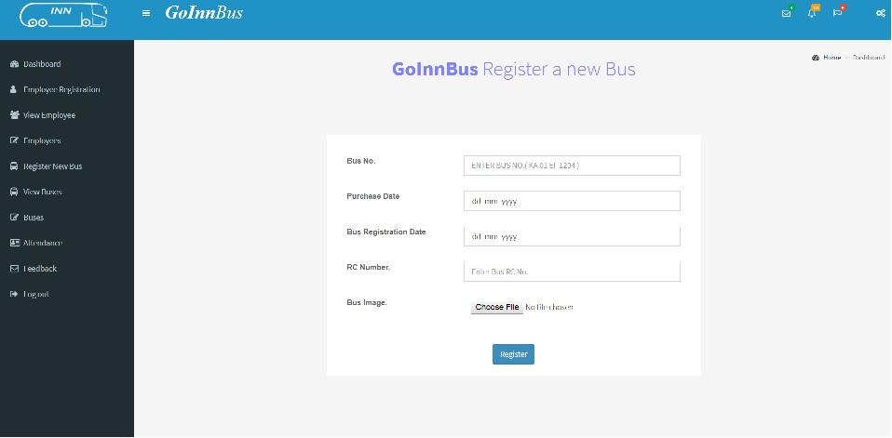

1. **View Registered Buses with abstract Information.** 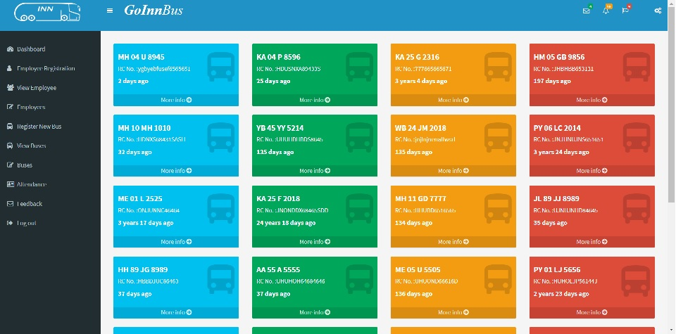
2. **Bus Information View.**

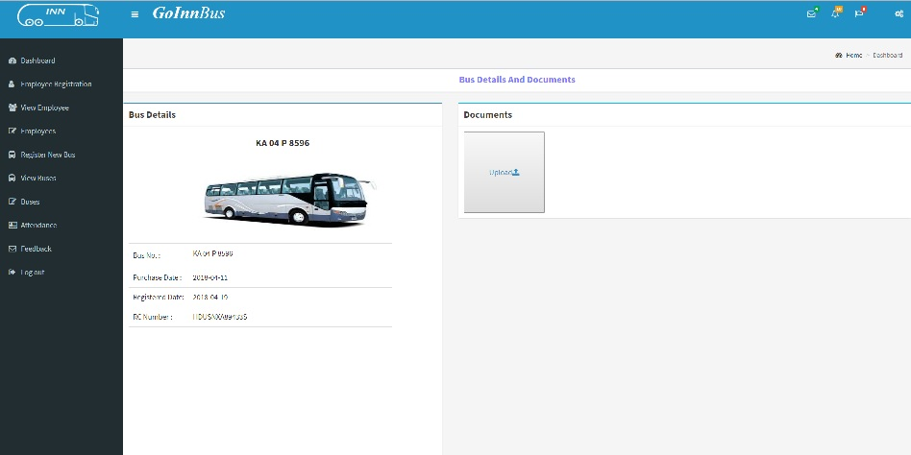

1. **Bus Documents Upload Form.**

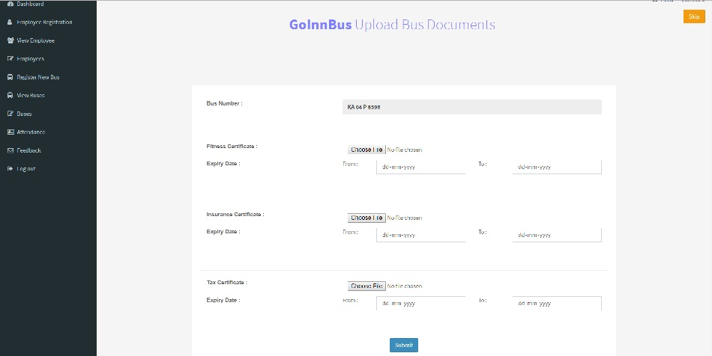

### Bus Information (after uploading bus documents).

### C:\Users\user\AppData\Local\Microsoft\Windows\INetCache\Content.Word\6.jpg

### View Complete List of Register Buses.C:\Users\user\AppData\Local\Microsoft\Windows\INetCache\Content.Word\7.jpg

### Feedback Form.

### C:\Users\user\AppData\Local\Microsoft\Windows\INetCache\Content.Word\8.jpg

### Login Form (Invalid Credentials).

### C:\Users\user\AppData\Local\Microsoft\Windows\INetCache\Content.Word\9.jpg

### Bus Registration Form (Validation Future Date id disable).

### C:\Users\user\AppData\Local\Microsoft\Windows\INetCache\Content.Word\11.png

### Locate buses on Map.

### 

### Locating Bus on the Map.

### 

### Locating bus with its details.

### 

**Chapter 8**

**CONCLUSION**

**In conclusion here you shall summarize your results and draw conclusions – not write how much you have learned, etc.**

**Please refer the following tips for writing conclusion.**

**Focus on your results, not just list up what you have done or how much you have learned by doing this, etc. – It is nice that you have learned a lot, but this is not relevant!!**

**Bad examples:**

**“I have learned much doing this assignment”**

**“This was very useful, and I will need this when I get a job”**

#### ****What are the typical 'ingredients' of a conclusion?****

* *A****summary****of the main part of the text*
* *A****deduction****made on the basis of the main body*
* *Your****personal opinion****on what has been discussed*
* *A statement about the****limitations****of the work*
* *A****comment about the future****based on what has been discussed*
* *The****implications****of the work for future research*
* *Important****facts and figures****not mentioned in the main body*

**For more details visit the link https://warwick.ac.uk/fac/soc/al/globalpad/openhouse/academicenglishskills/writing/conclusions/**

**“GoInBus”** is a web based application and it helps in easy management of bus details and also to know the exact location of the buses on the map for organization owner as well as higher level managers.

Facilities provided by the system

* Registration of new buses when a bus is purchased by the owner/organization.
* Bus documents can be maintained in the system without any fear of loosing them.
* Email notification can be sent to the owners/managers regarding the due date of the any bus documents.
* Users are also allowed to upload renewed bus documents to the system.
* Owner/higher level manager can modify/delete the bus along with details from the system whenever required.
* Users can send the feedback for the improvements of the system.

As the location of the bus can be known and hence the Owner/manager can get to know how much time the bus was idle at the particular bus station and hence necessary action can be taken for fraudulence done by the employees. As the system also maintains the bus documents, it notifies the owner/higher level manager regarding due date of any of the bus documents. Hence this system helps in easy management of the buses for its users.

**Chapter 9**

**BIBLIOGRAPHY**

**Websites**

**[1]** [**https //www.javatpoint.com/html-tutorial**](https://www.javatpoint.com/html-tutorial)

**[2]** [**https //www.javatpoint.com/php-tutorial**](https://www.javatpoint.com/php-tutorial)

**[3]** [**https //stackoverflow.com/**](https://stackoverflow.com/)

**[4]** [**https //www.quora.com/**](https://www.quora.com/)

**[5]** [**https //www.tutorialspoint.com/css/index.htm**](https://www.tutorialspoint.com/css/index.htm)

**[6]** [**https //stek.co.in/**](https://stek.co.in/)